**CSE3011 NETWORK PROGRAMMING**

**LAB EXPERIMENT 1**

NAME – B PRATYUSH

REGISTRATION NUMBER – 19BCN7114

LAB SLOT – L1+L2

FACULTY – PROF. MUNEESWARI

**QUESTION 1**

Find Fibonacci Series for a given value and calculate it's Average and Check if the average is prime or not.

**CODE**

import java.util.*;

public class fibonacci{

    public static int fib(int n)

    {

        int a0=0,a1=1;

        int temp=0;

        int a[]=new int[n];

        a[0]=a0;

        a[1]=a1;

        for(int i=2;i<n;i++)

        {

            temp=a0+a1;

            a0=a1;

            a1=temp;

            a[i]+=temp;

        }

        for(int i=0;i<n;i++)

        {

            System.out.print(a[i]+" ");

        }

        System.out.println();

        average(a);

        return temp;

    }

    public static int average(int[] x)

    {

        int avg=0;

        int sum=0;

        for(int i=0;i<x.length;i++)

        {

          sum+=x[i];

        }

        avg=sum/x.length;

        System.out.println("Average of the fibonaci series is: "+avg);

        System.out.print("The average of the fibonacci series is : ");

        isPrime(avg);

        return avg;

    }

    public static boolean isPrime(int n)

    {

        boolean flag=true;

        if(n==0|| n==1)

        {

            System.out.println("Neither prime nor composite");

        }

        else if(n==2)

        {

            System.out.println("Prime");

        }

        else

        {

            for(int i=2;i<n;i++)

            {

                if(n%i==0)

                {

                    flag=false;

                    System.out.print("Not Prime");

                    break;

                }

                else

                {

                    flag=false;

                    System.out.print("Prime");

                    break;

                }

            }

        }

        return flag;

    }

    public static void main(String [] args)

    {

        Scanner sin =new Scanner(System.in);

        System.out.println("Enter Size");

        int n=sin.nextInt();

        System.out.println("fibonacci series generated: ");

        fib(n);

    }

}

**OUTPUT**

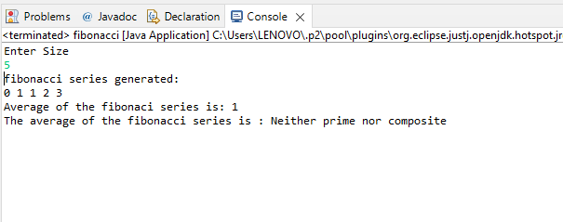

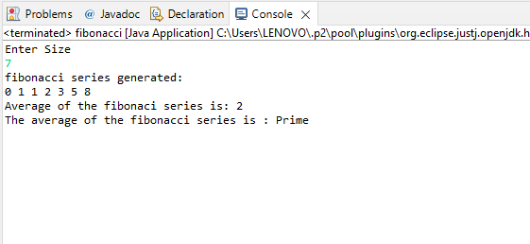

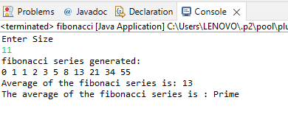

**QUESTION 2**

Find Average of 5 subjects of 50 Students and Find the grade of each student.

**CODE**

import java.util.*;

public class Main

{

public static char grade(double avg)

{

  char Gp;

    if(avg>90)

    {

        Gp='S';

    }

    else if(avg>81 && avg<=90)

    {

        Gp= 'A';

    }

    else if(avg>71 && avg<=80)

    {

        Gp= 'B';

    }

    else if(avg>61 && avg<=70)

    {

        Gp= 'C';

    }

    else if(avg>51 && avg<=60)

    {

        Gp= 'D';

    }

    else

    {

        Gp ='F';

    }

    System.out.println(Gp);

    return Gp;

}

public static void main(String[] args){

Scanner sin=new Scanner(System.in);

System.out.println("Enter number of students");

int n=sin.nextInt();

    double avg=0;

// Considering 50 as the maximum limit of students

    if(n<=50)

    {

      System.out.println("Entered number of students is within the max limit.Proceed!");

      for(int i=0;i<n;i++)

        {

          System.out.println("Enter Network Programming marks");

          double np=sin.nextInt();

          System.out.println("Enter Operating Systems marks");

          double os=sin.nextInt();

          System.out.println("Enter Data Analytics marks");

          double da=sin.nextInt();

          System.out.println("Enter Machine Learning marks");

          double ml=sin.nextInt();

          System.out.println("Enter Deep Learning marks");

          double dl=sin.nextInt();

          avg=((np+os+da+ml+dl)/250)*100;

          System.out.println("Percentage "+avg);

          System.out.println("Grade of student "+i+1+" is:"+grade(avg));

        }

    }

    else{

        System.out.println("Max limit is 50 students");

    }

}

}

**OUTPUT**

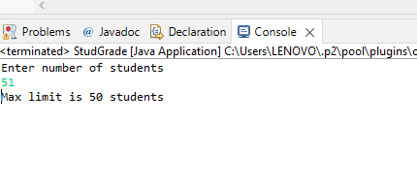

Enter number of students

2

Entered number of students is within the max limit.Proceed!

Enter Network Programming marks

34

Enter Operating Systems marks

50

Enter Data Analytics marks

46

Enter Machine Learning marks

39

Enter Deep Learning marks

23

Percentage 76.8

B

Grade of student 01 is:B

Enter Network Programming marks

45

Enter Operating Systems marks

50

Enter Data Analytics marks

18

Enter Machine Learning marks

38

Enter Deep Learning marks

34

Percentage 74.0

B

Grade of student 11 is:B

We can take marks for any value of students under the limit 50 and find their grade in similar way